The LaGrange-Troup County Chamber of Commerce cordially invites you to participate
in the 45th annual Christmas parade, presented by Kimberly-Clark!

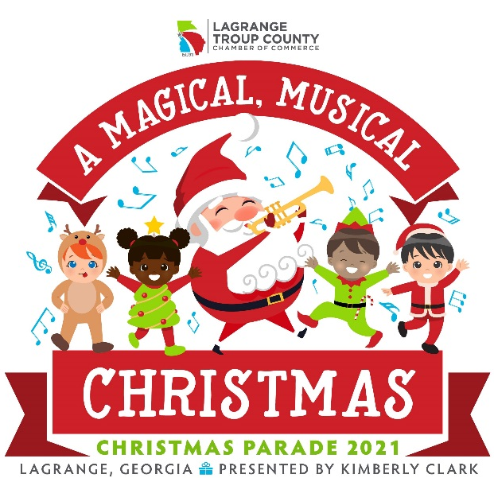
Thursday, December 2, 2021
6 p.m.

Parade Theme: “A Magical Musical Christmas”
Entry Categories: Church, Business, School, Civic, Industry and First-time Entry
Entry Fee: $40.00 per entry — including bands, floats, and motorized vehicles — plus
one unwrapped child’s toy.

Please return completed entry form, gift and fee by 5 p.m. on Monday, Nov. 15, to:

LaGrange-Troup County Chamber of Commerce
PO Box 636 – 111 Bull Street
LaGrange, GA 30241

No entries will be allowed after the deadline.

An award banner will be given for first and second place for the winning floats in each category.
This banner is to be carried in front of the float in the parade.
The number of entries will be limited to 80.

Please note the vehicle restrictions on the Information and Rules page.

Once payment and parade application are complete, you can pick up an entry number at our office.

Disclaimer:
The LaGrange-Troup County Chamber of Commerce reserves the right to deny participation to any entry that does not, in our opinion, represent the traditional Christmas spirit and/or the parade theme.

The Chamber of Commerce is not liable for any misadventure which may occur to anyone in or at the parade; however, we will do everything within our power to ensure everyone’s safety and enjoyment.

Questions:
Any questions may be directed to the LaGrange-Troup County Chamber of Commerce at (706) 884-8671

Information and Rules

Line-up Points:
- Marching Groups — St. Mark’s Episcopal Church back parking lot, no later than 5:30 p.m. A drop off point is provided for vehicles entering St. Mark’s lot from North Greenwood Street.
- Bands — Small parking lot next to LaGrange High expansion building by 5:30 p.m.
- Floats — Granger parking lot across from LaGrange High by 4:15 p.m.
- Vehicles — Those that comply with the description below, in Granger parking lot across from LaGrange High School by 4:15 p.m.
  - Trucks — No individuals may enter a truck or car in the parade. Trucks will only be allowed if they are decorated according to the parade theme and are carrying a group of people representing an organization. Trucks will not be allowed with only a business sign on them — instead, business trucks are encouraged to pull a float.
  - Cars — A convertible or an antique vehicle may be entered only if it is carrying a dignitary or winner of a pageant.
  - Other— No large vehicles (vans, RV’s, etc.) are allowed unless they are pulling a float.

When dropping off someone at the parade, do not drive through the line-up points at Granger Park.
No drop-offs will be allowed on North Greenwood Street and no traffic will be allowed on Granger Drive except floats.
There will be no parking on either side of North Greenwood in front of the school nor on Hunnicutt Place between North Greenwood and Granger Drive. Emory at LaGrange parking lot usually has available parking spaces.

Anyone driving a float and/or motorized vehicle must have a valid driver’s license and an entry number.

Santa Claus is a special guest and we ask that no other Santa be included in the parade.

When dropping off your application with payment and toy, you will receive your entry number.

Awards:
All floats must be in place and ready to be judged by 4:45 p.m. Judging will begin promptly at 5:00 p.m. In order for an entry to be considered for an award, the application form must be submitted and the entry fee paid no later than 5 p.m. on Monday, November 15. The same float cannot be entered year after year to be judged. Slow walkers & younger children MUST stay in float, two adults or fast-walking children are allowed to carry banners.

Safety:
We require that all children’s groups arrive as a group with an adult leader. Group leaders, please stay with your group after the parade until each child has been picked up by his/her parent/guardian.
No more than 20-25 walkers allowed, slower walkers need to be in float if applicable.

Tossing, throwing or handing out any item into the crowd is prohibited and you will be removed from the parade.

Foghorns are prohibited, as they scare small children.
Walking groups may not stop to perform along the parade route. (i.e. dancing, karate)

Route:
The parade will begin at Granger Park and head south on North Greenwood Street.
**Specific route details to be provided at a later time**

2021 Parade Application

Name of Organization: ___

Circle One Category:
Church | Small Business | School
Civic | Large Business/Industry | First-Time Entry
Contact Person:

Name | Mailing Address
Email Address |  | Daytime Phone

Circle One Entry Type:
Float | Dignitary Vehicle | Youth/Marching | Other*
Band | People/Animals | Adult/Marching

Please write the size of your vehicle entry below. Examples: Truck pulling 45-foot trailer, automobile only, go- cart, etc. *These entries will be reviewed by the parade coordinator.

Please attach a brief description of your entry to be used for purposes of publicity. We will take reasonable precaution to protect your description; however, we reserve the right to edit as necessary.

The annual Christmas parade is a community project
and we sincerely thank you in advance for your support!

Final Agreement:
I have read the 2021 Christmas Parade Information and Rules and will adhere to the same. I do not hold the Chamber liable in case of misadventure.

Signature

Printed Name Date

CHAMBER USE ONLY: $40 Entry Fee Child’s Toy

*Please be advised that no refunds will be issued.*

